Zotero citation manager tutorial

In order to get the most out of Zotero you need to download Zotero, the Chrome/Firefox plug-in, and the Microsoft plug-in. There are detailed instructions in Zotero.org and a substantial amount of troubleshooting fixes. Follow the steps provided in the webpage and once you have all three elements in place, we can start the tutorial for this great, free, and useful tool.

Zotero is especially useful for four things:
- Literature database.
  - Personal
  - Shared
- Getting literature from the net.
- In-text citation management.
- Report generating.

Literature data base
Zotero as a personal database

This is the Zotero interface:

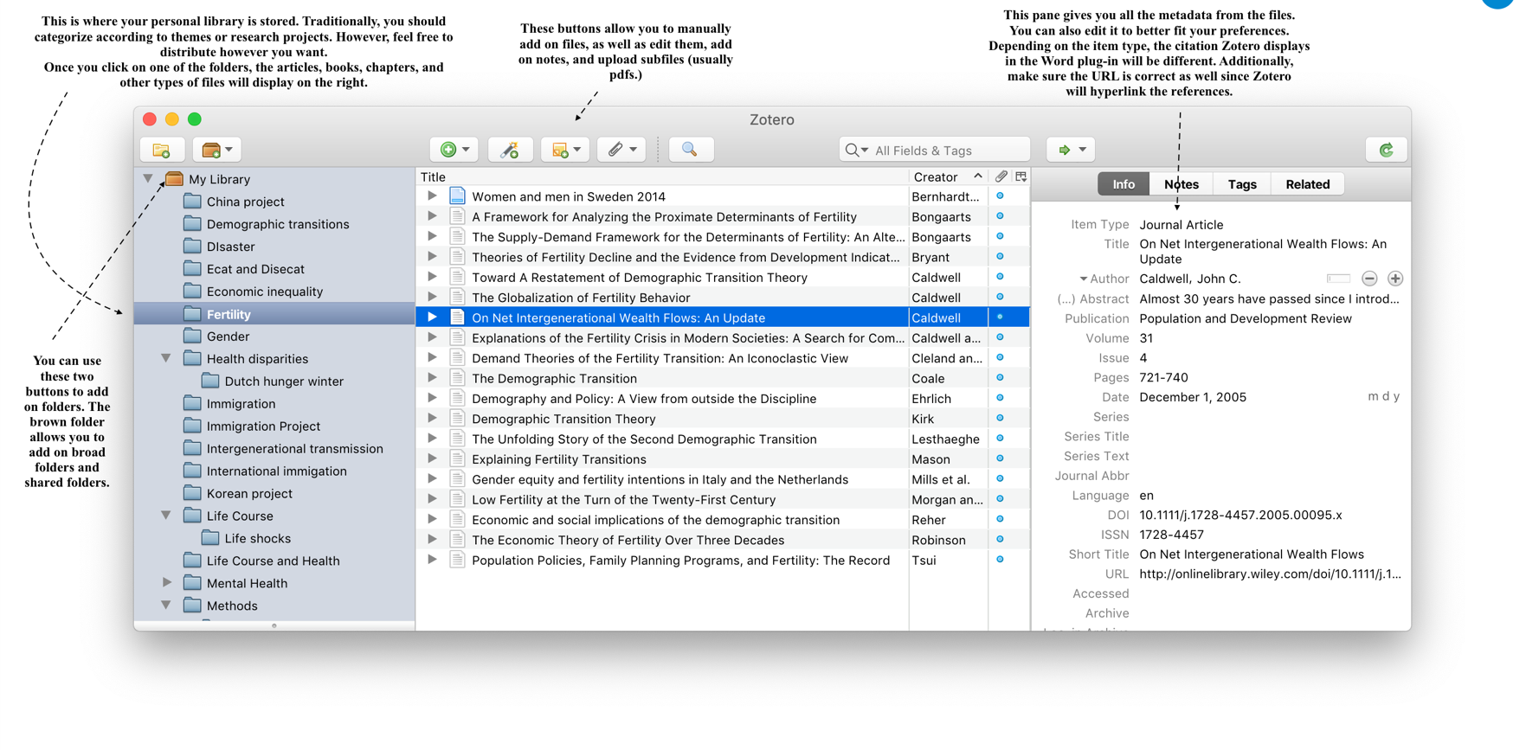
In order to add on to the Zotero database, you simply have to drag and drop the pdf file you would like to store in to your preferred folder. Once you’ve dropped it in, right click on the pdf file and click on the item “retrieve metadata”. This will save you a lot of time, since Zotero will read the pdf file and scout the internet to retrieve all its information -e.g. author, publication, date, etc.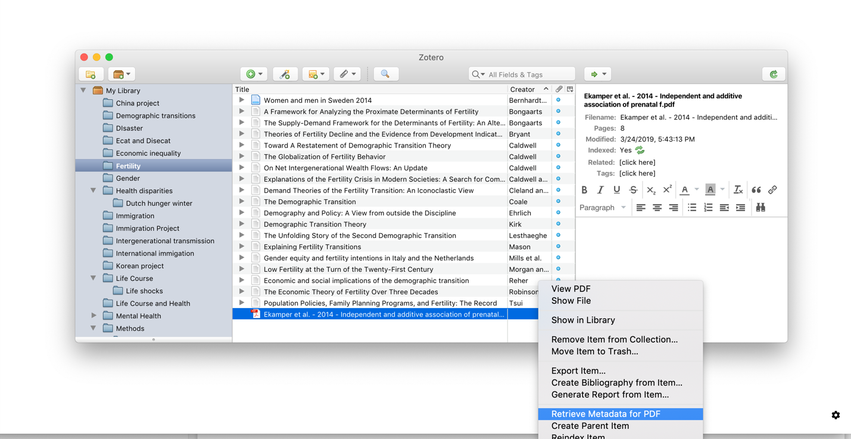

Zotero as a shared database

Another great feature for Zotero is that you can share literature with other Zotero users. This is especially useful for research teams that need to be synchronized. Furthermore, if you happen to work on several devices and you would like to have access to your library, Zotero synchronizes and stores information across devices.

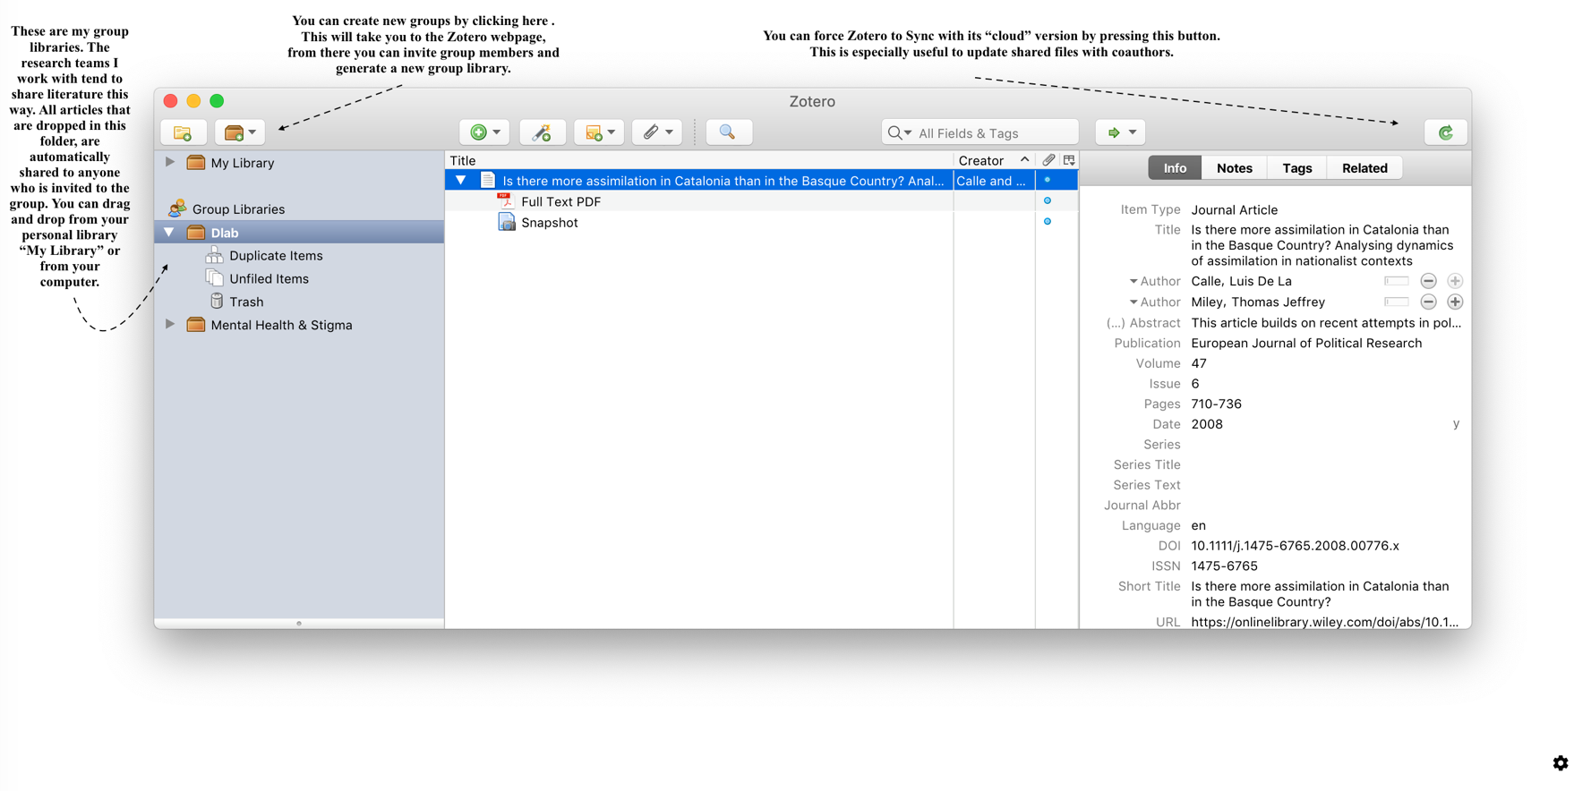

Getting literature from the net.
For this section of the tutorial we will need the Chrome plug-in. Zotero supports Firefox as well. You will know Zotero is integrated in your browser because a small “article” shaped icon will appear in the right hand corner. In order to download an article into Zotero, you simply need to click the icon and Zotero will do all the work for you.
The file will be stored in the most recently opened folder in your Zotero interface. Hence, you should click on the folder you want your articles to land in before you download the article. Usually, you will be doing literature review of one topic at a time, so this system works well.

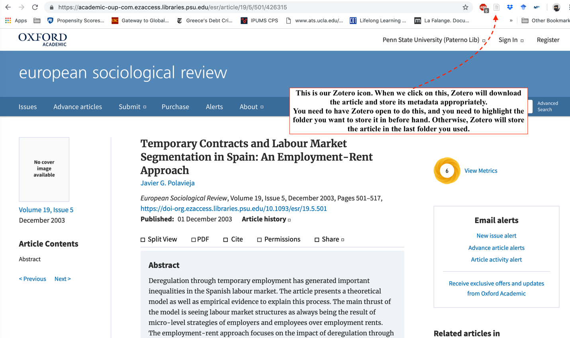

In-text citation management
Zotero provides plug-ins for several text softwares. We will use Word but know that Zotero is integrated for open source programs such as Libreoffice as well. Review the steps to download and integrate Zotero to Word. You will know it’s integrated once you see a tab on top of the tool bar.

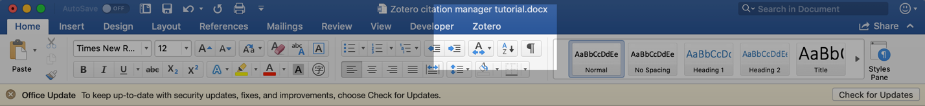

Just like when we use the Zotero browser plugin to download articles, we need to have Zotero open as well.

The Word plugin has two functions: add a citation, and add/edit reference section.

When you are writing, you can click on add/edit a citation and Zotero will open a window that allows you to feed from your literature database. For example:

First, we write our sentence:

Ethnic boundaries can become brighter in light of important political events that allow identities to become more salient (CITATION).

Once we know where the citation goes, we stop there and click the Zotero add/edit citation button. Usually, Zotero will ask you in what style you wish to cite. You can add new styles by clicking on the “manage styles” button on the bottom right.

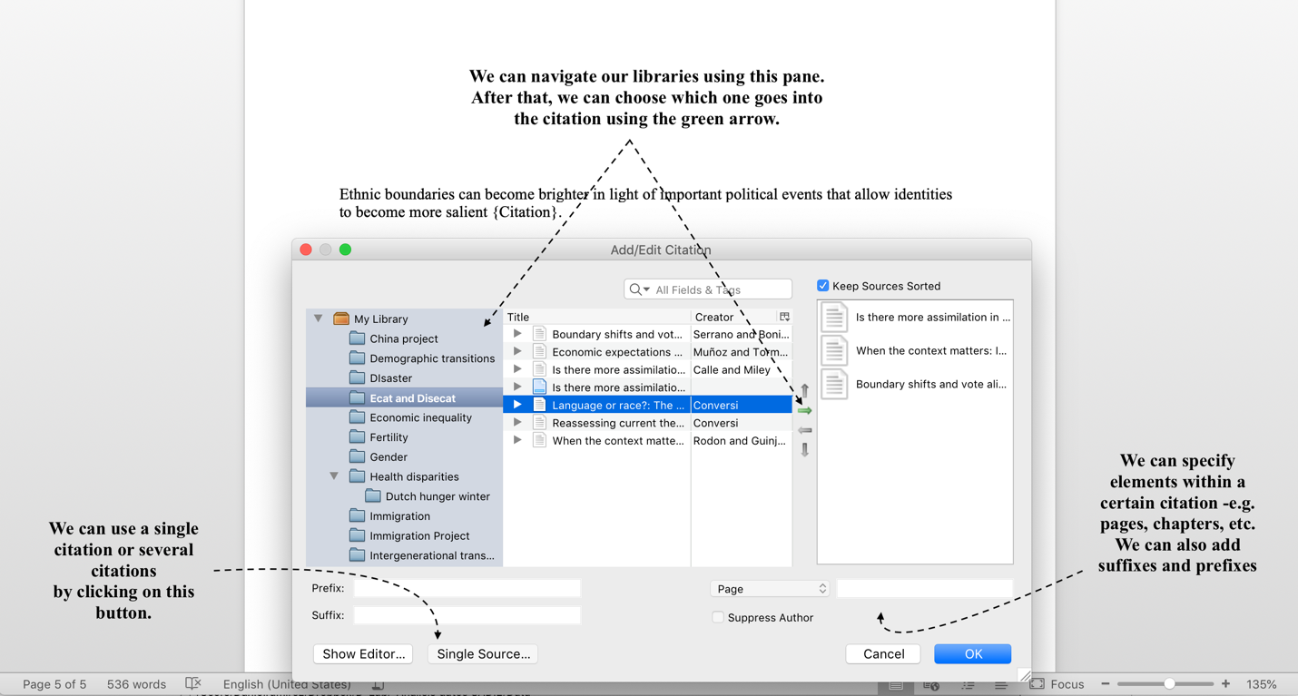

This is our result:

Ethnic boundaries can become brighter in light of important political events that allow identities to become more salient (Calle and Miley 2008; Rodon and Guinjoan 2018; Serrano and Bonillo 2017).

Once you are done writing and citing, with one simple click you can immediately create a reference section. Zotero feeds from all the citations you’ve displayed throughout the article and generates a clean and homogenous styled reference section. In order to do that, you just need to click on the “Add/edit Bibliography” button.

If we were to click on the “Add/edit Bibliography” button for our previous example, this is what we would get:

Ethnic boundaries can become brighter in light of important political events that allow identities to become more salient (Calle and Miley 2008; Rodon and Guinjoan 2018; Serrano and Bonillo 2017).

References
Calle, Luis De La and Thomas Jeffrey Miley. 2008. “Is There More Assimilation in Catalonia than in the Basque Country? Analysing Dynamics of Assimilation in Nationalist Contexts.” European Journal of Political Research 47(6):710–36.
Rodon, Toni and Marc Guinjoan. 2018. “When the Context Matters: Identity, Secession and the Spatial Dimension in Catalonia.” Political Geography 63:75–87.
Serrano, Ivan and Albert Bonillo. 2017. “Boundary Shifts and Vote Alignment in Catalonia.” Ethnicities 17(3):371–91.

Report generating
Zotero is extremely useful to generate quick bibliographies and reports. Let’s imagine you are working on literature review for your advisor or you need to share a quick literature review report for a coauthor. Zotero can do this very quickly for you. Highlight the articles you wish to generate a report for, right click on them and select the “Generate report from items” option.

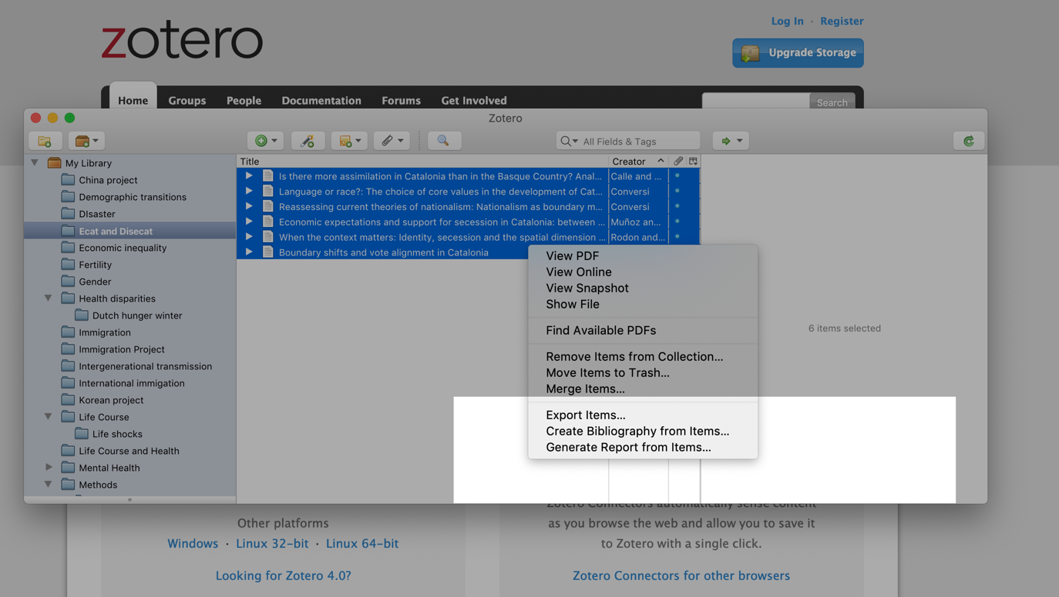

The result will be a large and detailed citation that contains the abstract. Here is an example of the format for one of the articles:

Zotero allows you to copy the bibliography into your clipboard and paste it wherever you like. Highlight the articles you wish to include in your bibliography, right click on them, and then select “Create bibliography from item”. The result for our example is as follows:

Calle, Luis De La and Thomas Jeffrey Miley. 2008. “Is There More Assimilation in Catalonia than in the Basque Country? Analysing Dynamics of Assimilation in Nationalist Contexts.” European Journal of Political Research 47(6):710–36.
Conversi, Daniele. 1990. “Language or Race?: The Choice of Core Values in the Development of Catalan and Basque Nationalisms.” Ethnic and Racial Studies 13(1):50–70.
Conversi, Daniele. 1995. “Reassessing Current Theories of Nationalism: Nationalism as Boundary Maintenance and Creation.” Nationalism and Ethnic Politics 1(1):73–85.
Muñoz, Jordi and Raül Tormos. 2015. “Economic Expectations and Support for Secession in Catalonia: Between Causality and Rationalization.” European Political Science Review 7(2):315–41.
Rodon, Toni and Marc Guinjoan. 2018. “When the Context Matters: Identity, Secession and the Spatial Dimension in Catalonia.” Political Geography 63:75–87.
Serrano, Ivan and Albert Bonillo. 2017. “Boundary Shifts and Vote Alignment in Catalonia.” Ethnicities 17(3):371–91.

One final mention about Zotero’s potential is the timeline generator. If you click on the Tools >Timeline tab, you can create a timeline of when the articles you have selected were published:

